# KISI fakulteti AT-servis yo’nalishi 680-23-guruh talabasi Abdullajonov Muhammadqodirning sun’iy intellect asoslari fanidan 2-amaliy mashg’ulotda bajargan ishi

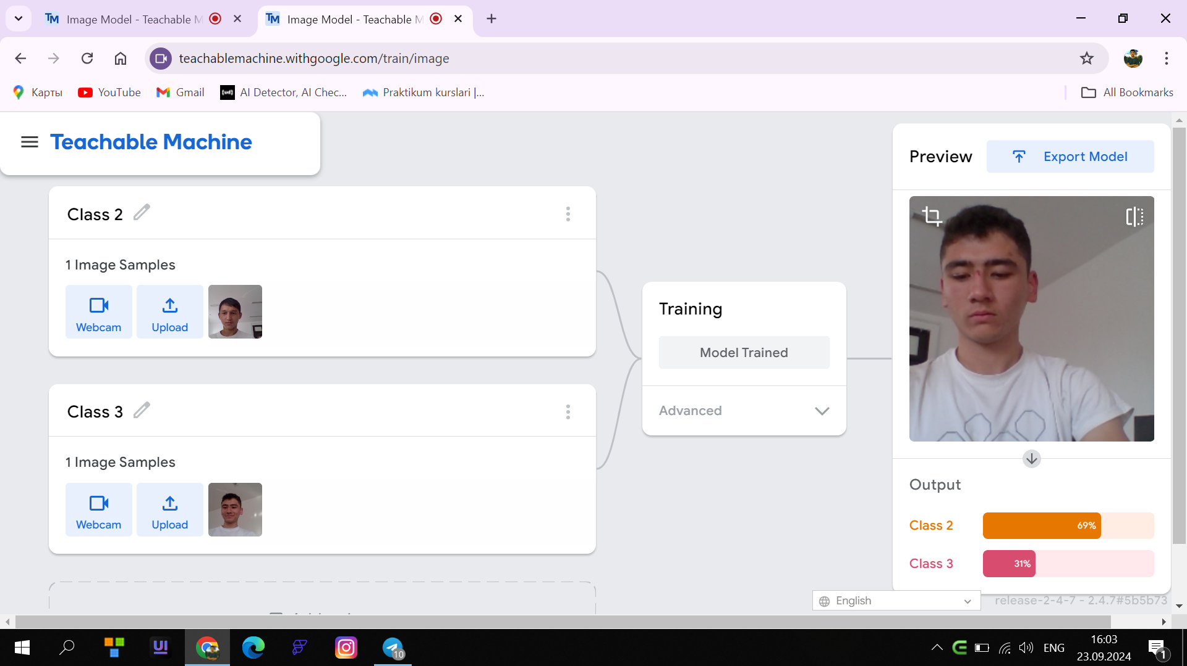

<div>Teachable Machine Image Model</div>

<button type="button" onclick="init()">Start</button>

<div id="webcam-container"></div>

<div id="label-container"></div>

<script src="https://cdn.jsdelivr.net/npm/@tensorflow/tfjs@latest/dist/tf.min.js"></script>

<script src="https://cdn.jsdelivr.net/npm/@teachablemachine/image@latest/dist/teachablemachine-image.min.js"></script>

<script type="text/javascript">

// More API functions here:

// https://github.com/googlecreativelab/teachablemachine-community/tree/master/libraries/image

// the link to your model provided by Teachable Machine export panel

const URL = "./my_model/";

let model, webcam, labelContainer, maxPredictions;

// Load the image model and setup the webcam

async function init() {

const modelURL = URL + "model.json";

const metadataURL = URL + "metadata.json";

// load the model and metadata

// Refer to tmImage.loadFromFiles() in the API to support files from a file picker

// or files from your local hard drive

// Note: the pose library adds "tmImage" object to your window (window.tmImage)

model = await tmImage.load(modelURL, metadataURL);

maxPredictions = model.getTotalClasses();

// Convenience function to setup a webcam

const flip = true; // whether to flip the webcam

webcam = new tmImage.Webcam(200, 200, flip); // width, height, flip

await webcam.setup(); // request access to the webcam

await webcam.play();

window.requestAnimationFrame(loop);

// append elements to the DOM

document.getElementById("webcam-container").appendChild(webcam.canvas);

labelContainer = document.getElementById("label-container");

for (let i = 0; i < maxPredictions; i++) { // and class labels

labelContainer.appendChild(document.createElement("div"));

}

}

async function loop() {

webcam.update(); // update the webcam frame

await predict();

window.requestAnimationFrame(loop);

}

// run the webcam image through the image model

async function predict() {

// predict can take in an image, video or canvas html element

const prediction = await model.predict(webcam.canvas);

for (let i = 0; i < maxPredictions; i++) {

const classPrediction =

prediction[i].className + ": " + prediction[i].probability.toFixed(2);

labelContainer.childNodes[i].innerHTML = classPrediction;

}

}

</script>